Project Design Phase-II
Data Flow Diagram & User Stories

Date | 05-12-2025
Team ID
Project Name | BookStore
Maximum Marks | 4 Marks

BookStore is a MERN-based online book shopping platform where users can discover, search, and purchase books, while admins manage inventory, orders, and user activity through a secure dashboard. The system supports role-based authentication, responsive UI, and scalable backend services to deliver a complete e-commerce experience for books.​

Data Flow Diagram description
- External entities: Customer (User), Admin, and Payment Gateway interact with the system through the web interface.​
- Core processes: User Authentication, Book Browsing & Search, Cart & Checkout, Order Management, and Admin Management handle all main operations.​
- Data stores: User Database, Book Database, Order Database, and Review Database persist all application data

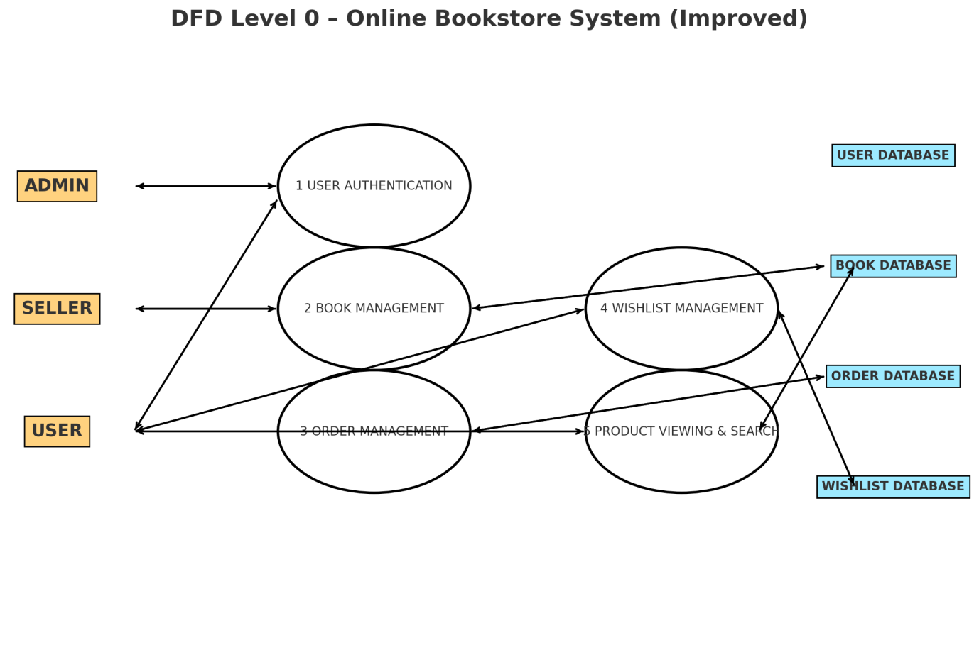

User Type | Functional Requirement (Epic) | User Story / Task | Acceptance Criteria | Priority | Release
Customer | Book Browsing | As a customer, I can browse and search books by title, author, genre, or rating. | Relevant books are listed with correct filters and pagination.image.jpg​ | High | Sprint-1
Customer | Cart & Checkout | As a customer, I can add books to a cart and complete a secure checkout. | Cart shows selected books, payment succeeds, and an order is created.image.jpg​ | High | Sprint-1
Customer | Review System | As a customer, I can leave a review and rating for purchased books. | Review appears on the book detail page and is linked to my account.image.jpg​ | Medium | Sprint-2
Admin | Book Management | As an admin, I can create, edit, and remove book records. | Changes are stored in the Book Database and visible on the storefront.image.jpg​ | High | Sprint-1
Admin | Order Management | As an admin, I can view and update the status of customer orders. | Order status updates are saved and shown in the customer’s order history.image.jpg​ | High | Sprint-2
User | Authentication | As a user, I can register and log in securely to access my account. | Valid credentials return a JWT and redirect to the dashboard.image.jpg​ | High | Sprint-1

